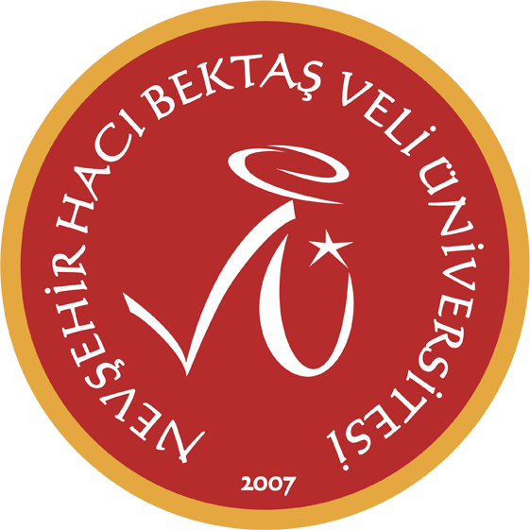
2025 - 2026 Bahar Dönemi
Yasemin Aktaş

 | Pazartesi | Sali | Carsamba | Persembe | Cuma
08:30 09:15
09:30 10:15 |  | MC - MAIN COURSE (SPC C)  YDYO 3 |  | MC – MAIN COURSE (SPC G)  YDYO 8 | MC - MAIN COURSE (SPC C)  YDYO 3
10:30 11:15 | MC – MAIN COURSE (SPC G)  YDYO 8 | MC - MAIN COURSE (SPC C)  YDYO 3 | MC – MAIN COURSE (SPC G)  YDYO 8 | MC – MAIN COURSE (SPC G)  YDYO 8 | MC - MAIN COURSE (SPC C)  YDYO 3
11:30 12:15 | MC – MAIN COURSE (SPC G)  YDYO 8 | MC - MAIN COURSE (SPC C)  YDYO 3 | MC – MAIN COURSE (SPC G)  YDYO 8 | MC – MAIN COURSE (SPC G)  YDYO 8 | MC - MAIN COURSE (SPC C)  YDYO 3
12:30 13:30
13:30 14:15 | Office Hour | MC – MAIN COURSE (SPC G)  YDYO 8 |  | MC - MAIN COURSE (SPC C)  YDYO 3
14:30 15:15 | Office Hour | MC – MAIN COURSE (SPC G)  YDYO 8 | CA- CLUB ACTIVITIES (SPC D)  YDYO 4 | MC - MAIN COURSE (SPC C)  YDYO 3
15:30 16:15 |  | MC – MAIN COURSE (SPC G)  YDYO 8 | CA- CLUB ACTIVITIES (SPC D)  YDYO 4
16:30 17:15
17:30 18:15

